**INTRODUCTION**

Grafana is a visualization tool which used data sources like Azure Monitor, Elasticsearch, CloudWatch etc. for displaying data graphically. This article will concentrate on using Azure Monitor plugin for Monitoring Azure VMs and various features provided by Grafana for actively monitoring Azure VMs.

This first part of this article will describe a typical installation, with basic configurations and Azure

Monitor as data source.

1. Installation
2. Configuration
3. Datasource
4. Dashboards (key)

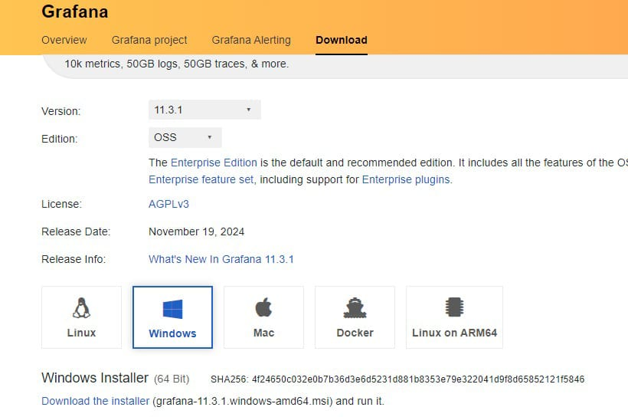

1. **Installation**

Grafana provides two versions of the tool:

1. OSS
2. Enterprise

This article shows installation of the latest Grafana Enterprise edition on Linux VM (Ubuntu 18.04).

**2.Configuration**

Once installation is done open the Grafana tool

Default username and password is admin which needs to be changed at first login.

Replace YOUR-IP with the public IP address of the VM where Grafana is installed



Grafana uses Azure Monitor as a data source to fetch data in real time from Azure service for this we need to create a service Principal and assign below permissions to the SPN:

1. Reader permission at subscription level. This is needed to read all the resources present in the subscription via Azure Monitor.
2. Log analytics Reader Permission for the subscription to read data from Azure log analytics.

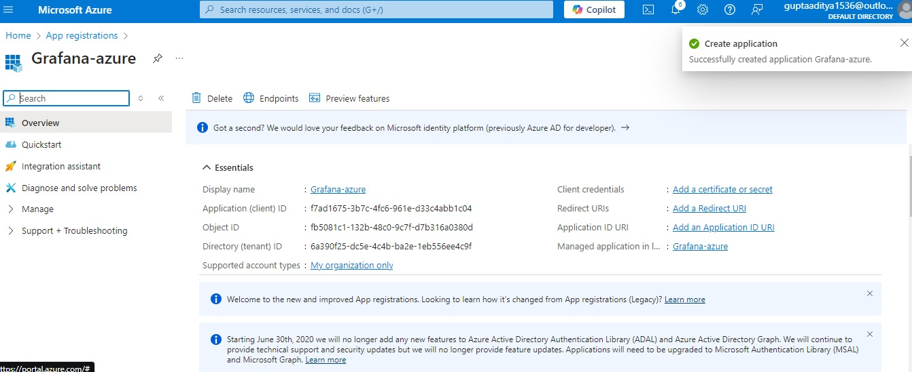

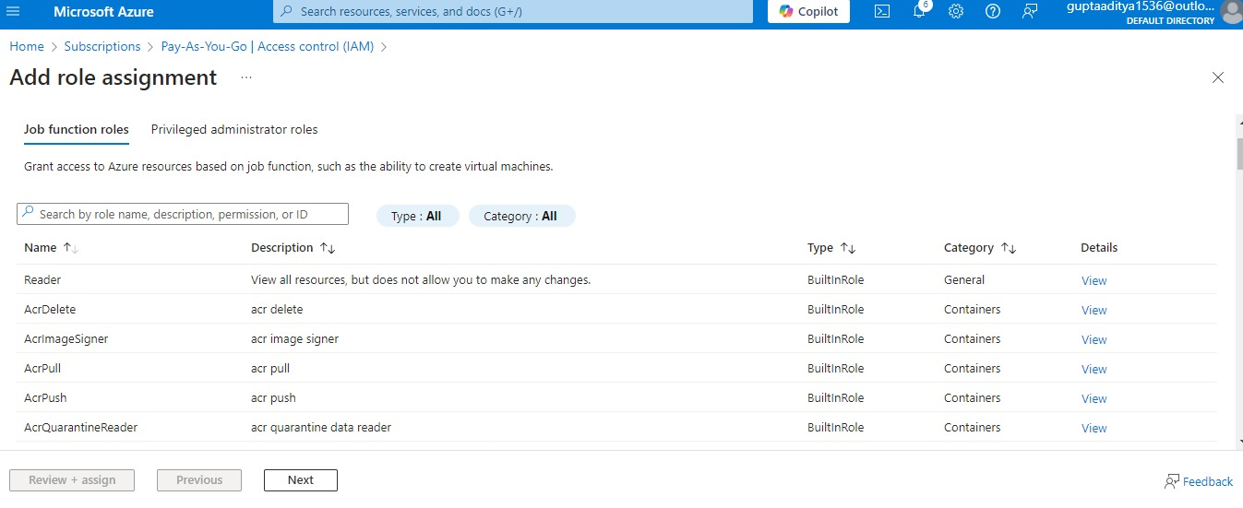

1. Log analytics API permission. (Active Directory -> API Permission -> Adda permission)
2. 



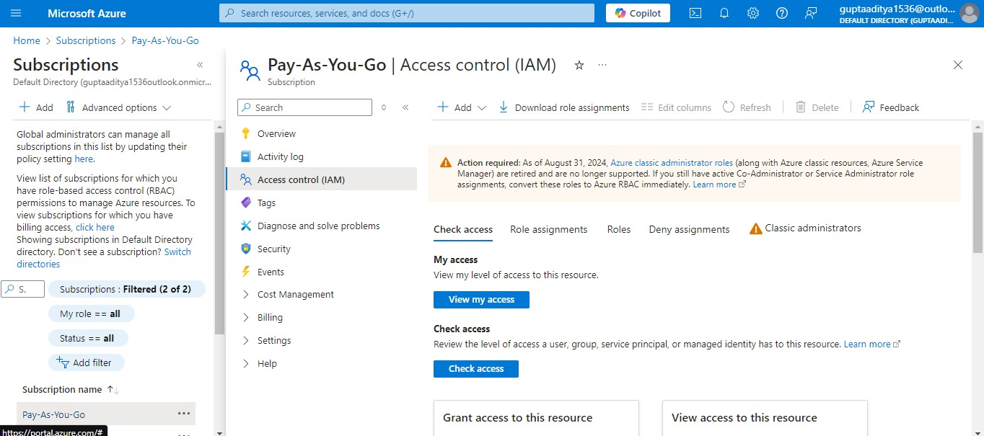

Once the SPN with required permissions is created, configure the Azure Monitor Data Source using the below steps:

1. **Datasource**
2. Open the Grafana Instance on browser and go to Data sources
3. Click on the Add Source and search for Azure Monitor
4. Fill the details of SPN in the data source.

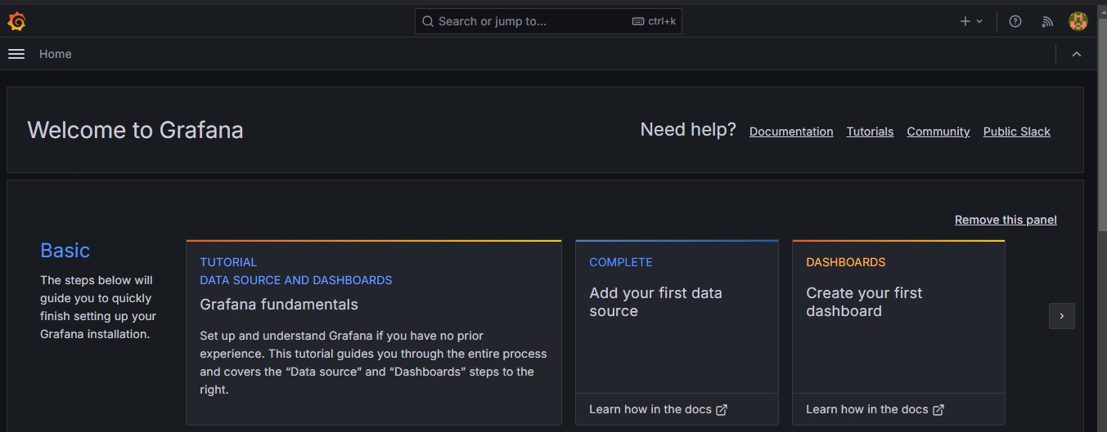

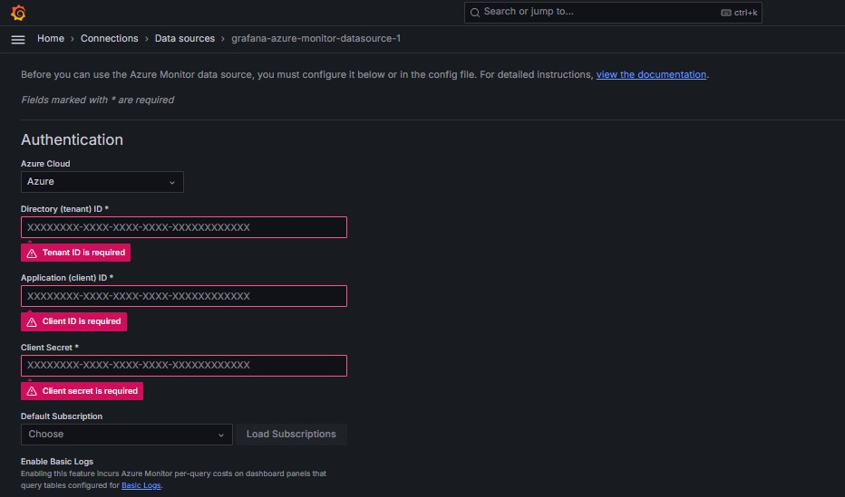

1. **Dashboards**

